**Create an image file of your ERD.**

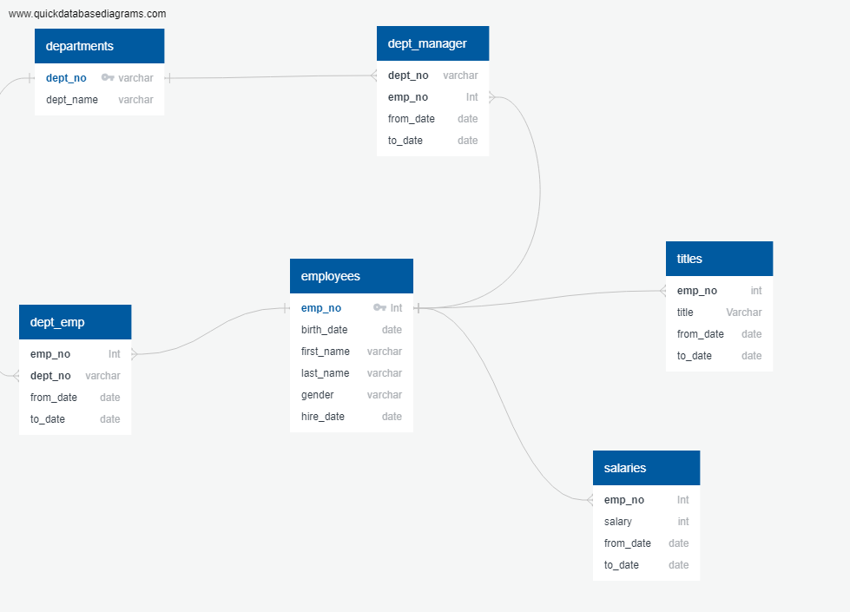

* **Create a `.sql` file of your table schemata.**

-- Exported from QuickDBD: https://www.quickdatabasediagrams.com/

-- Link to schema: https://app.quickdatabasediagrams.com/#/d/Hiv3ij

-- NOTE! If you have used non-SQL datatypes in your design, you will have to change these here.

-- Modify this code to update the DB schema diagram.

-- To reset the sample schema, replace everything with

-- two dots ('..' - without quotes).

DROP TABLE IF EXISTS departments;

DROP TABLE IF EXISTS dept_emp;

DROP TABLE IF EXISTS dept_manager;

DROP TABLE IF EXISTS employees;

DROP TABLE IF EXISTS salaries;

DROP TABLE IF EXISTS titles;

CREATE TABLE "departments" (

"dept_no" varchar NOT NULL,

"dept_name" varchar NOT NULL,

CONSTRAINT "pk_departments" PRIMARY KEY (

"dept_no"

)

);

CREATE TABLE "dept_emp" (

"emp_no" Int NOT NULL,

"dept_no" varchar NOT NULL,

"from_date" date NOT NULL,

"to_date" date NOT NULL

);

CREATE TABLE "dept_manager" (

"dept_no" varchar NOT NULL,

"emp_no" Int NOT NULL,

"from_date" date NOT NULL,

"to_date" date NOT NULL

);

CREATE TABLE "employees" (

"emp_no" Int NOT NULL,

"birth_date" date NOT NULL,

"first_name" varchar NOT NULL,

"last_name" varchar NOT NULL,

"gender" varchar NOT NULL,

"hire_date" date NOT NULL,

CONSTRAINT "pk_employees" PRIMARY KEY (

"emp_no"

)

);

CREATE TABLE "salaries" (

"emp_no" Int NOT NULL,

"salary" int NOT NULL,

"from_date" date NOT NULL,

"to_date" date NOT NULL

);

CREATE TABLE "titles" (

"emp_no" int NOT NULL,

"title" Varchar NOT NULL,

"from_date" date NOT NULL,

"to_date" date NOT NULL

);

ALTER TABLE "dept_emp" ADD CONSTRAINT "fk_dept_emp_emp_no" FOREIGN KEY("emp_no")

REFERENCES "employees" ("emp_no");

ALTER TABLE "dept_emp" ADD CONSTRAINT "fk_dept_emp_dept_no" FOREIGN KEY("dept_no")

REFERENCES "departments" ("dept_no");

ALTER TABLE "dept_manager" ADD CONSTRAINT "fk_dept_manager_dept_no" FOREIGN KEY("dept_no")

REFERENCES "departments" ("dept_no");

ALTER TABLE "dept_manager" ADD CONSTRAINT "fk_dept_manager_emp_no" FOREIGN KEY("emp_no")

REFERENCES "employees" ("emp_no");

ALTER TABLE "salaries" ADD CONSTRAINT "fk_salaries_emp_no" FOREIGN KEY("emp_no")

REFERENCES "employees" ("emp_no");

ALTER TABLE "titles" ADD CONSTRAINT "fk_titles_emp_no" FOREIGN KEY("emp_no")

REFERENCES "employees" ("emp_no");

**\* Create a `.sql` file of your queries**.

1. List the following details of each employee: employee number, last name, first name, gender, and salary.

select employees.emp_no as "Employee Number",

employees.last_name as "Last Name",

employees.first_name as "First Name",

employees.gender as "Gender",

salaries.salary as "Salary"

from employees

inner join salaries on employees.emp_no=salaries.emp_no

2. List employees who were hired in 1986.

select

last_name as "Last Name",

first_name as "First Name",

hire_date as "Hire Date"

from employees

where hire_date between '1986-01-01' and '1987-01-01'

order by hire_date asc;

3. List the manager of each department with the following information: department number, department name, the manager's employee number, last name, first name, and start and end employment dates.

select

dm.dept_no as "Department Number",

d.dept_name as "Department Name",

dm.emp_no as "Employee Number",

e.last_name as "Last Name",

e.first_name as "First Name",

dm.from_date as "Start Date",

dm.to_date as "End Date"

from dept_manager as dm

inner join departments as d

on dm.dept_no =d.dept_no

inner join employees as e

on dm.emp_no = e.emp_no;

4. List the department of each employee with the following information: employee number, last name, first name, and department name.

select

e.emp_no as "Emplpoyee Name",

e.last_name as "Last Name",

e.first_name as "First Name",

d.dept_name as "Department Name"

from employees as e

inner join dept_emp

on e.emp_no = dept_emp.emp_no

inner join departments as d

on d.dept_no =dept_emp.dept_no;

5. List all employees whose first name is "Hercules" and last names begin with "B."

select first_name as "First Name",

last_name as "Last Name"

from employees

where first_name = 'Hercules' and last_name Like'B%';

6. List all employees in the Sales department, including their employee number, last name, first name, and department name.

select

e.emp_no as "Employee Number",

d.dept_name as "Department Name",

e.last_name as "Last Name",

e.first_name as "First Name"

from employees as e

inner join dept_emp as de

on e.emp_no = de.emp_no

inner join departments as d

on de.dept_no = d.dept_no

where dept_name ='Sales';

7. List all employees in the Sales and Development departments, including their employee number, last name, first name, and department name.

select

e.emp_no as "Employee Number",

d.dept_name as "Department Name",

e.last_name as "Last Name",

e.first_name as "First Name"

from employees as e

inner join dept_emp as de

on e.emp_no = de.emp_no

inner join departments as d

on de.dept_no = d.dept_no

where dept_name ='Development' or dept_name = 'Sales';

8. In descending order, list the frequency count of employee last names, i.e., how many employees share each last name.

select last_name as "Last Name",

count(last_name) as "Frequency"

from employees

group by last_name

order BY count(last_name) desc;